**DAY-7 Assignment**

**Name- Dibya Ranjan Rath**

**SIC- 20BCSE62 GitHub-** <https://github.com/Dibya1771/MERN.git>

**1st React app:**

**Output:**

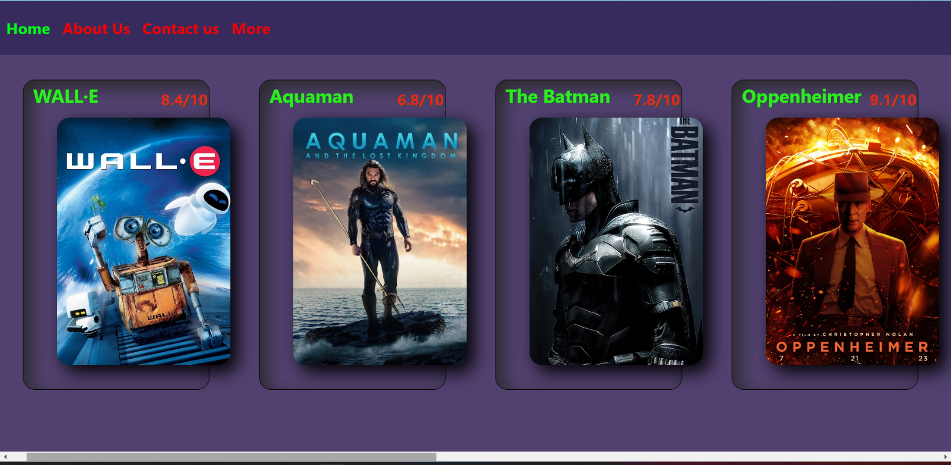(Sample Output-1

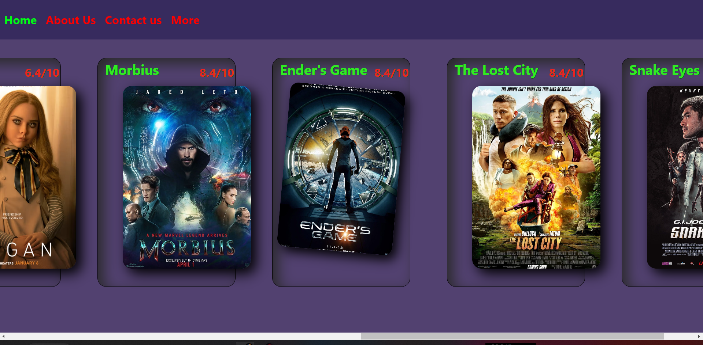(Sample Output-2

**Code:**

File name- app.js

import logo from './logo.svg';

import './App.css';

import Navbar from "./components/navbar";

import Card from "./components/card";

function App() {

  const data=[{

    image: "https://encrypted-tbn0.gstatic.com/images?q=tbn:ANd9GcSxYd3qWb7UlM_UBeis23ZV3SHzJpNy9-aBeScMnEzLHO1zc0wD",

    title: "WALL·E",

    rating: "8.4/10",

},

{

    image: "https://lh3.googleusercontent.com/B4cnobWyvdonq4TQ-ijq0tVNnKWo3ZwhPpEOQu2llSxuXLKyhTtSg9gmPhFrZC6MaLV03rD5aFm8_Kl2WDdcbP7P8TwimH8ZucRY34IB=w500-rw",

    title: "Aquaman",

    rating: "6.8/10",

},

{

    image: "https://images-cdn.ubuy.co.in/639c88534d20d83575030186-the-batman-movie-poster-profile-blue.jpg",

    title: "The Batman",

    rating: "7.8/10",

},

{

    image: "https://pbs.twimg.com/media/FvYLAURaEAIwqq0?format=jpg&name=medium",

    title: "Oppenheimer",

    rating: "9.1/10",

},

{

    image: "https://static1.moviewebimages.com/wordpress/wp-content/uploads/2022/12/mv5bmdk4mtdhyzetodk3os00zdbjlwfhntqtmdi2oddjnzqzzta3xkeyxkfqcgdeqxvymjmxote0oda-_v1_.jpg?q=50&fit=crop&h=720&dpr=1.5",

    title: "Megan",

    rating: "6.4/10",

},

{

    image: "https://e1.pxfuel.com/desktop-wallpaper/49/663/desktop-wallpaper-new-movie-posters-hollywood-movie-2022.jpg",

    title: "Morbius",

    rating: "8.4/10",

},

{

    image: "https://e1.pxfuel.com/desktop-wallpaper/214/87/desktop-wallpaper-lovely-new-hollywood-movies-poster-movies-hollywood.jpg",

    title: "Ender's Game",

    rating: "8.4/10",

},

{

    image: "https://e1.pxfuel.com/desktop-wallpaper/19/469/desktop-wallpaper-new-movie-posters-hollywood-movie-2022.jpg",

    title: "The Lost City",

    rating: "8.4/10",

},

{

    image: "https://e1.pxfuel.com/desktop-wallpaper/236/875/desktop-wallpaper-new-giclee-art-print-2021-promo-for-snake-eyes-g-i-joe-hollywood-2022-movies-poster.jpg",

    title: "Snake Eyes",

    rating: "8.4/10",

}

];

  return (

<div>

<Navbar />

<div className='after-nav' >

{data.map((el) => {

  return( <Card image={el.image} title={el.title} rating={el.rating} />);

  })}

</div>

</div>

  );

}

export default App;

File name- navbar.jsx

import React from "react";

import "./navbar.css";

function Navbar(){

    return(

    <div className="App-nav">

        <div className="text-nav">

            <h1 className="home">Home</h1>

            <h1>About Us</h1>

            <h1>Contact us</h1>

            <h1>More</h1>

   </div>

   </div>

    );

}

export default Navbar;

File name- navbar.css

.App-nav{

    flex-direction: row;

    margin-top: -20px;

    position: fixed;

    width: 100%;

}

.text-nav{

    background-color: #0c084162;

    display: flex;

    color: rgb(255, 0, 0);

}

h1{

    padding: 10px;

    font-size: 25px;

}

.home{

    color: #00ff15;

}

File name- card.jsx

import React from "react";

import "./card.css"

function Card({title,image,rating}){

    return(

        <div className="parrent-pic">

        <div className="head-name">

        <h1>{title}</h1>

        <h4>{rating}</h4>

            <img style={{width: '280px',height:'400px'}}

            className="img-move"

            src={image}

             alt="error" />

        </div>

    </div>

    );

}

export default Card;

File name- card.css

body{

    background: #1e0846c4;

}

.parrent-pic{

    display: flex;

}

.after-nav{

    display: flex;

    margin: 20px;

}

.head-name{

    border-radius: 20px;

    box-shadow: inset 12px 12px 30px #292929;

    margin-left: 5rem;

    margin-top: 28%;

    width: 300px;

    height: 500px;

    border: 1px solid #000000;

    /* rotate: -2deg; */

}

.head-name h1{

    color: #30ec23;

    font-size: 30px;

    margin-left: 2%;

    text-shadow: 1px 1px #005e05;

    margin-top: -5px;

}

.head-name h4{

    color: #ec2323;

    font-size: 25px;

    margin-left: 74%;

    text-shadow: 1px 1px #005e05;

    margin-top: -20%;

}

.img-move{

    border-radius: 20px;

    box-shadow: 11px 11px 28px #000;

    margin-left: 18%;

    margin-top: -20px;

    object-fit: cover;

    /* rotate: 1deg; */

}

.img-move:hover{

    zoom: 90%;

    margin-left: 8%;

    transition: 0.4s;

    rotate: 5deg;

}

____x____